Come Join

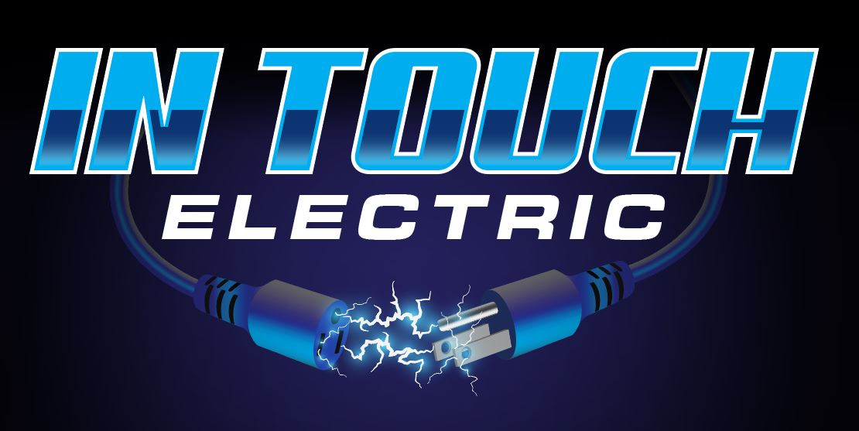

**At the Port St. Lucie Home Show**

Septmeber 13-14  
**Sat. 10-5 • Sun. 10-4**

Free Admission

**MIDFLORIDA Credit Union Event Center**  
(formerly **Port St. Lucie Civic Center)**

Off Walton Road  
9221 SE Event Center Place,  
Port St. Lucie, Florida 34952

* **Generator Installation, warranty and Maintenance**
* **LP Gas tank installation**
* **Lighting, Light Fixtures, Plugs, Outlets**
* **Ceiling Fans**
* **Panel installation, Change, Relocation and Upgrades**
* **Failed 4.1 inspection, (loose wires, double taps, no cover)**
* **Electric car charger installation**
* **Portable generator 30/50amp circuits**
* **Cummins and Generac Generator dealer.**