Come Join

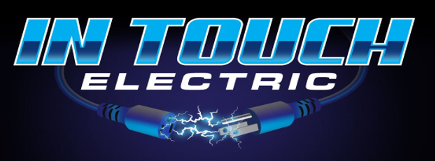

At the Port St. Lucie Home Show
January 17th-18th

Free Admission

MIDFLORIDA Credit Union Event Center
(formerly Port St. Lucie Civic Center)
Off Walton Road
9221 SE Event Center Place,
Port St. Lucie, Florida 34952

- Generator Installation, warranty and maintenance
- LP Gas tank installation
- Lighting, Light Fixtures, Plugs, Outlets
- Ceiling Fans
- Panel installation, Change, Relocation and Upgrades
- Failed 4.1 inspection (loose wires, double taps, no cover)
- Electric car charger installation
- Portable generator 30/50amp circuits
- Cummins and Generac Generator dealer.

